Type of Analysis:

Two-Way Interactions with Categorical M (Model 1)

Model Visualization:

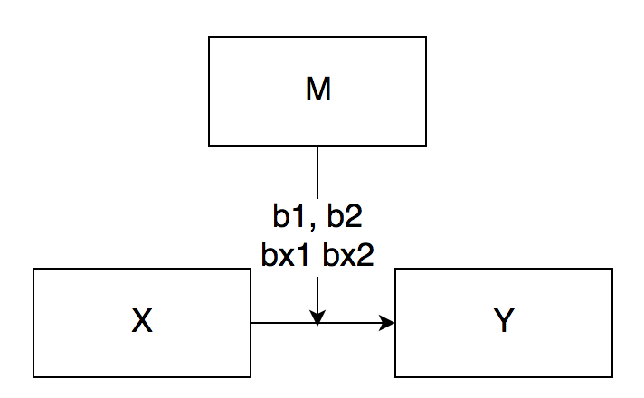

IV(s):

* Illiteracy

DV:

* Income

M:

* Murder (categorical, Low/Average/High)

Power:

Figure out how many IVs going to be.

Illiteracy (continuous) (1)

Murder (categorical) 🡪 K-1 number of variables (2)

Interaction 🡪 Number for X times the number for M = (2)

One group gets coded as all zeroes

One group gets coded as 1 and then zeroes

One group gets coded as zero and then 1

|  |  |  |
| --- | --- | --- |
| Group | Var 1 | Var 2 |
| Low | 0 | 0 |
| Average | 1 | 0 |
| High | 0 | 1 |

Each variable represents group with all zeroes versus group with a 1.

First way for overall R2 all 5 predictors

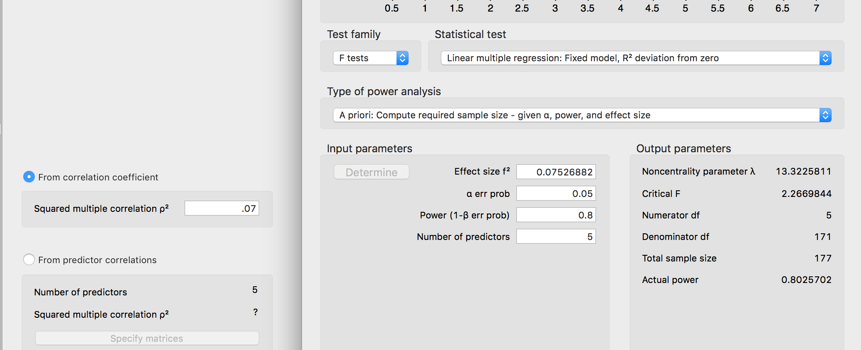

Second way for increase in R2 just the interaction 2 predictors

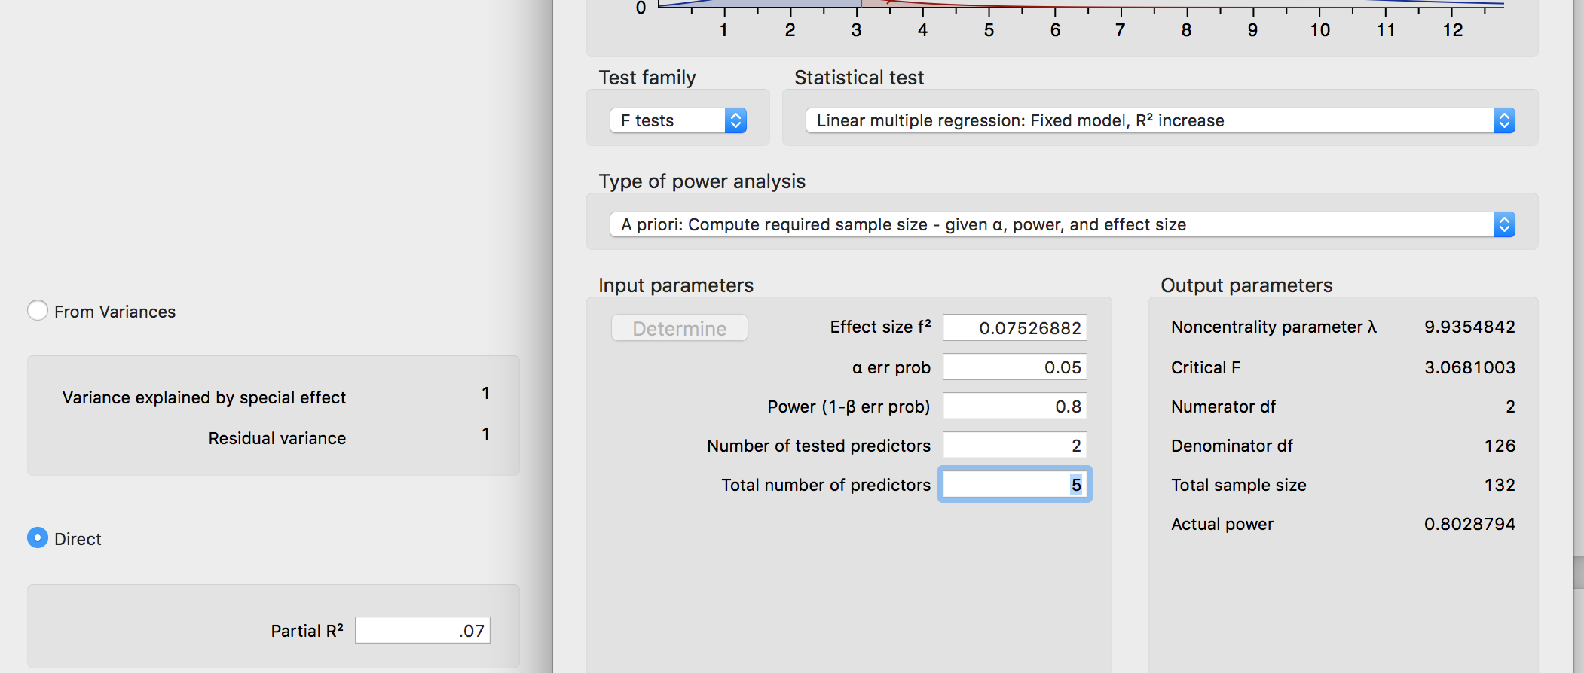

Data Screening:

* Accurate Data

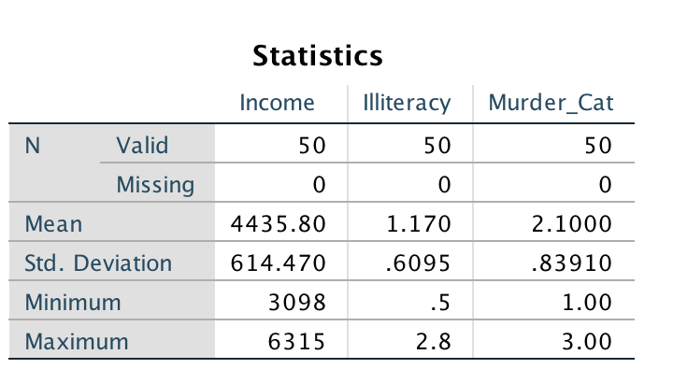

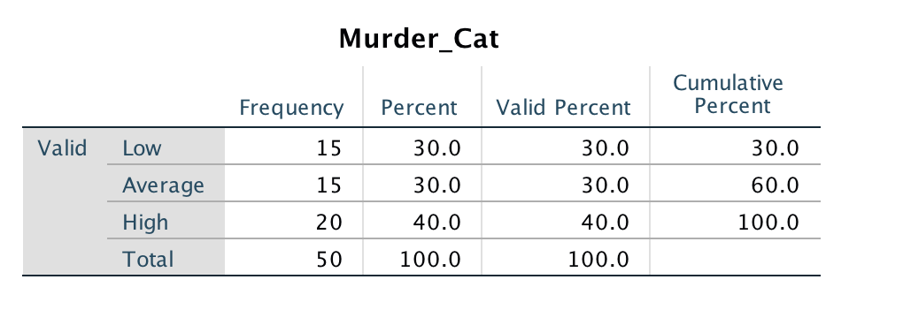

* Missing Data

No missing data see above.

* Outliers
  + Mahalanobis
    - DF = number of IV variables in the equation (1)
    - Cut off equals = 10.83
    - P < .001

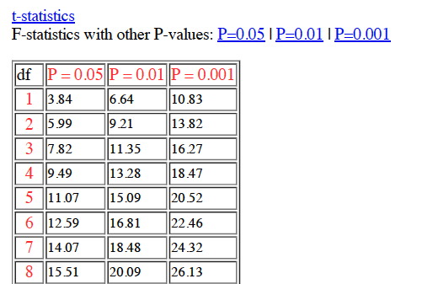

* + Cooks
    - 4/(N – k – 1)
    - 4/(50 – 1 – 1) = .083
  + Leverage
    - (2K + 2)/N
    - (2*1 + 2)/50 = .080
* Assumptions:
  + Additivity

Not necessary because only one continuous IV.

* + Normality

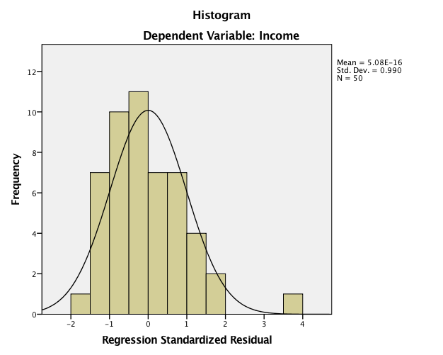

* + Linearity

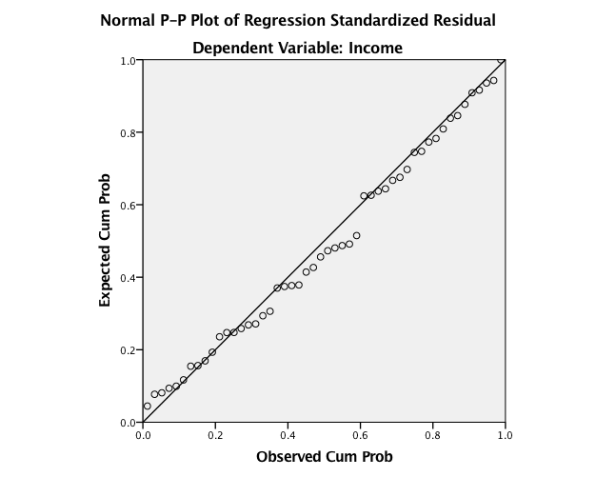

* + Homogeneity/Homoscedasticity

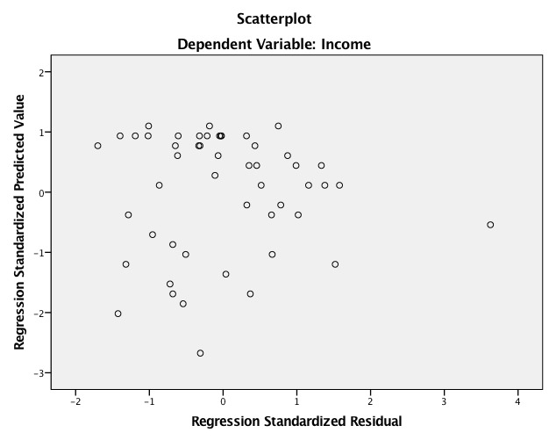

Analysis:

Run MATRIX procedure:  
  
**************** PROCESS Procedure for SPSS Version 3.00 *****************  
  
          Written by Andrew F. Hayes, Ph.D.       www.afhayes.com  
    Documentation available in Hayes (2018). www.guilford.com/p/hayes3  
  
**************************************************************************  
Model  : 1  
    Y  : Income  
    X  : Illitera  
    W  : Murder_C  
  
Sample  
Size:  50  
  
Coding of categorical W variable for analysis:  
 Murder_C       W1       W2  
    1.000     .000     .000  
    2.000    1.000     .000  
    3.000     .000    1.000

W1 average versus low

W2 high versus low   
  
**************************************************************************  
OUTCOME VARIABLE:  
 Income

Model Summary  
          R       R-sq        MSE          F        df1        df2          p  
      .6105      .3727 263747.293     5.2294     5.0000    44.0000      .0007

*F*(5, 44) = 5.23, *p* = .007, *R2* = .37

Model  
              coeff         se          t          p       LLCI       ULCI  
constant  4830.8299   281.8085    17.1422      .0000  4262.8761  5398.7837  
Illitera   622.6639   569.4554     1.0934      .2802  -525.0103  1770.3381  
W1        -291.8224   317.4927     -.9191      .3630  -931.6937   348.0490  
W2        -122.7710   317.5633     -.3866      .7009  -762.7846   517.2426  
Int_1     -497.7119   655.4463     -.7593      .4517 -1818.6912   823.2674  
Int_2    -1525.2361   601.3278    -2.5364      .0148 -2737.1456  -313.3266

Illiteracy *b* = 662.66, *t*(44) = 1.09, *p* = .280, not predictive, as illiteracy increases, income also increases

W1 average versus low *b* = -291.82, *t*(44) = -0.92, *p* = .363, difference in income between average and low, not significant

W2 high versus low *b* = -122.77, *t*(44) = -0.39, *p* = .701, difference in come between low and high, not significant

Int 1 average versus low BY illiteracy *b* = -497.71 …. No interaction

Int 2 high versus low BY illiteracy *b* = -1525.24 … significant, yes interaction

Product terms key:  
 Int_1    :        Illitera x        W1  
 Int_2    :        Illitera x        W2  
  
Test(s) of highest order unconditional interaction(s):  
       R2-chng          F        df1        df2          p  
X*W      .1695     5.9442     2.0000    44.0000      .0052 (addition of interaction to R2)  
----------  
    Focal predict: Illitera (X)  
          Mod var: Murder_C (W)

Conditional effects of the focal predictor at values of the moderator(s):  
  
   Murder_C     Effect         se          t          p       LLCI       ULCI  
     1.0000   622.6639   569.4554     1.0934      .2802  -525.0103  1770.3381  
     2.0000   124.9521   324.5464      .3850      .7021  -529.1353   779.0394  
     3.0000  -902.5722   193.1727    -4.6724      .0000 -1291.8903  -513.2540

Simple slopes: slopes for X to Y given a level / group of M

Low group (1) illiteracy predicting income *b* = 622.66 … not significant

Average group (2) illiteracy predicting income *b* = 124.95 … not significant

So at low and average levels of murder rates, illiteracy does not predict income

High group (3) illiteracy predicting income *b* = -902.57 … significant, at high murder rates, illiteracy predicts a decrease in income rates by 902 points.

*********************** ANALYSIS NOTES AND ERRORS ************************  
  
Level of confidence for all confidence intervals in output:  
  95.0000  
  
NOTE: The following variables were mean centered prior to analysis:  
          Illitera  
  
NOTE: Variables names longer than eight characters can produce incorrect output.  
      Shorter variable names are recommended.  
  
------ END MATRIX -----